*fEMR*

Product Design Specification

Version *1.0*

*03/05/2016*

VERSION HISTORY

|  |  |  |  |  |  |
| --- | --- | --- | --- | --- | --- |
| **Version**  **#** | **Implemented**  **By** | **Revision**  **Date** | **Approved**  **By** | **Approval**  **Date** | **Reason** |
| 1.0 | *Arooba Javed* | *03/05/2016* | *Khayyam Hashmi* |  | Initial Design Definition draft |
|  |  |  |  |  |  |
|  |  |  |  |  |  |

**UP Template Version:** 12/31/07

TABLE OF CONTENTS

1 Introduction 2

1.1 Purpose of The Product Design Specification Document 2

2 General Overview and Design Guidelines/Approach 3

2.1 Assumptions / Constraints / Standards. 3

3 Architecture Design 3

3.1 Hardware Architecture. 4

3.2 Software Architecture. 4

3.3 Security Architecture. 4

3.4 Communication Architecture. 4

3.5 Performance. 4

4 System Design.. 5

4.1.a Use-Case Diagrams. 5

4.1.b Use-Case Tables

4.2 Sequence Diagram.. 17

4.3 Data Flow Diagram.. 21

4.4 Database Design. 22

4.5 Class Diagram.. 23

4.6 Application Program Interfaces. 23

4.7 User Interface Design. 27

5 Product Design Specification Approval.. 28

Appendix A: References. 29

Appendix B: Key Terms. 29

**1** **Introduction**

## **1.1** **Purpose of The Product Design Specification Document**

This Product Design Specification Document will summarize the design specifications for the fEMR project. The fEMR project involves designing and creating several new web pages that will integrate with the existing fEMR website. These new web pages will add important additional functions to the fEMR website. The Product Design Specification document documents and tracks the necessary information required to effectively define architecture and system design in order to give the development team guidance on architecture of the system to be developed. The Product Design Specification document is created during the Planning Phase of the project. Its intended audience is the project manager, project team, and development team. Some portions of this document such as the user interface (UI) may on occasion be shared with the client/user, and other stakeholder whose input/approval into the UI is needed.

# **2** **General Overview and Design Guidelines/Approach**

## **2.1** **Assumptions / Constraints / Standards**

**Assumptions:**

* The software is used by transient medical team members.
* The user has a stable internet connection, with a modern browser

**Constraints:**

* The basic webpage development portion of this project will be using HTML and CSS along with some JavaScript
* The database will be implemented using MySQL which will be combined with PHP to handle the storing of web page inputs from our survey. MySQL is used to manipulate the databases used for this project.
* A premade forum implementation will be used to create our discussion board.
* A map API will be used to aid in the creation of our interactive map.
* GitHub is used as a repository and version control.
* The project must be completed and the final source code submitted by April 19th, 2016
* There is a class schedule, with deadlines for specific documents and prototypes that must be adhered to
* We must purchase a Laracast subscription in order to learn the technology properly to code this project. The subscription is inexpensive, at $9/month and will be purchased as a group (each group member will pitch in $3).

**Standards:**

* This project must follow the quality standards set forth by our client (these standards are discussed verbally with the client at regular meetings).

# **3** **Architecture Design**

This section outlines the system and hardware architecture design of the system that is being built. There are four major databases in this application: Users, Trip Database, Literature Bank and Places. The Users database contains the email addresses and passwords of registered fEMR users, the Trip Database contains trip information, the Places Database contains information regarding each place visited on a medical mission trip and the Literature Bank Database contains resources that registered fEMR users have posted to the site. In order for data to be added to the Trip Database and the Literature Bank, moderator approval is required.

## **3.1** **Hardware Architecture**

The web pages are accessed via a user’s personal desktop computer or laptop that has a secure internet connection. In addition, a user may access the web pages via a mobile device (mobile functionality is slightly altered to fit the smaller screen and slower load time). The database information is stored on the fEMR server, which the client owns and controls.

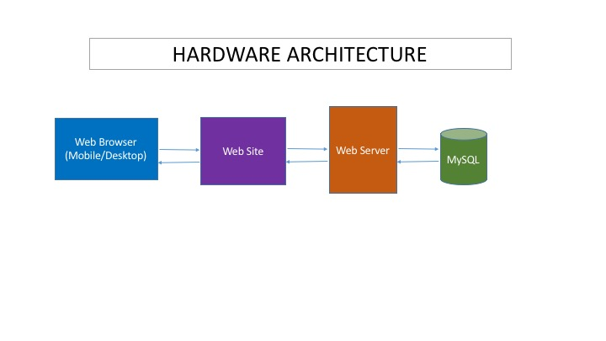

**3.2** **Software Architecture**

The software is set up in different sections. The user interface section, or the web pages being accessed by the user, are structured in the Model-View Controller (MVC) model. This model allows the web pages to display the data and the user to access the data. This model provides the communication link between the databases and the web pages.

In addition, we are using Object-relational mapping to convert the database information to xml, which is then sent to the map API and displayed on the Trip Database page.

## **3.3** **Security Architecture**

fEMR users must create a secure login and password in order to contribute to the Trip Database, Discussion Board and Literature Bank. A registered user gains the ability to post to these pieces of the software product, while an unregistered user has read-only access. In addition, the fEMR product will have moderators who have the ability to approve users’ submissions to the Trip Database and Literature Bank. These users have access to all parts of all web pages.

## **3.4** **Communication Architecture**

The users may communicate with each other via the Discussion Board. The Discussion Board implementation as a separate web page. In addition, users may submit a survey on the Trip Database page and the Literature Bank to contribute to each of these web pages (with moderator approval).

## **3.5** **Performance**

The performance of our web pages should be responsive on all accessing devices. Serving of web pages and database queries should be quick and should take no more than 4 seconds for a given web page to be served to a device.

Through extensive testing we will confirm that our webpages will run at least 98% of the time depending on external services such as local servers. Once a user uploads a survey, the fEMR representative will be sent an email requesting approval. We are dependent on our web hosting provider.

The webpages and their various features will be available at least 98% of the time (excluding web provider and server connectivity issues) to users who have a stable internet connection on devices.

**4** **System Design**

## **4.1.a** **Use Case Diagrams**

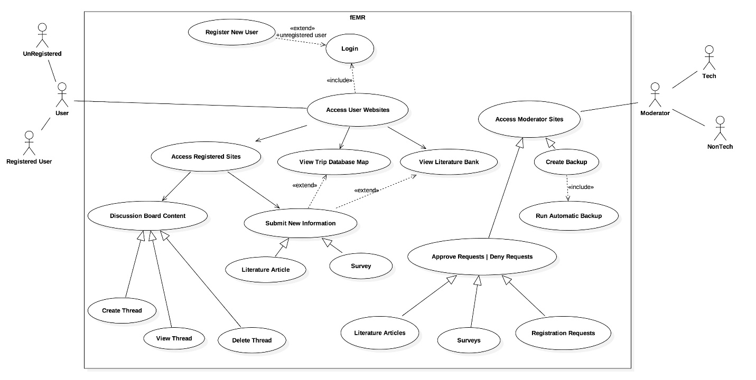

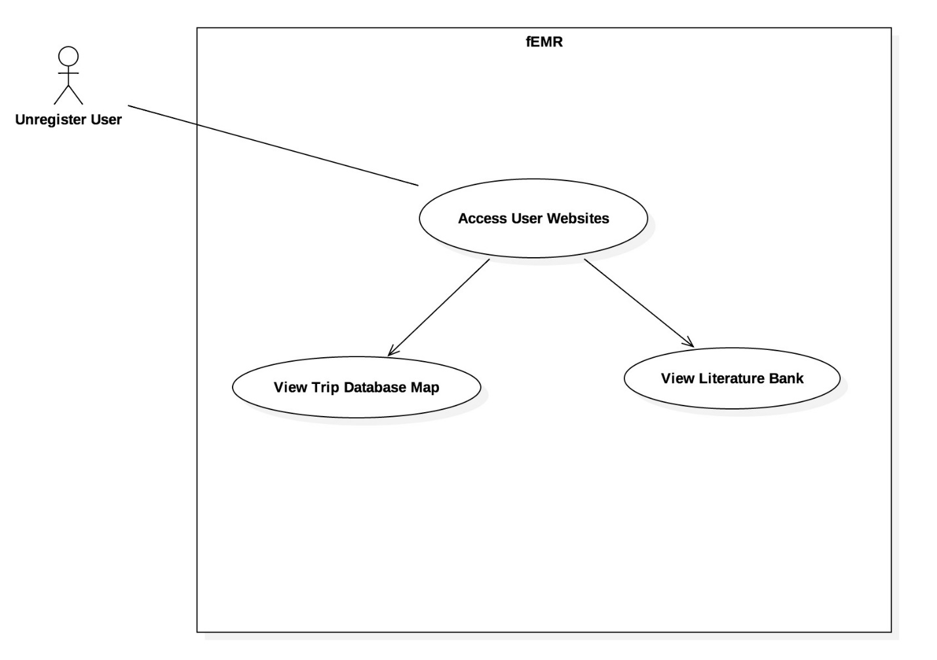

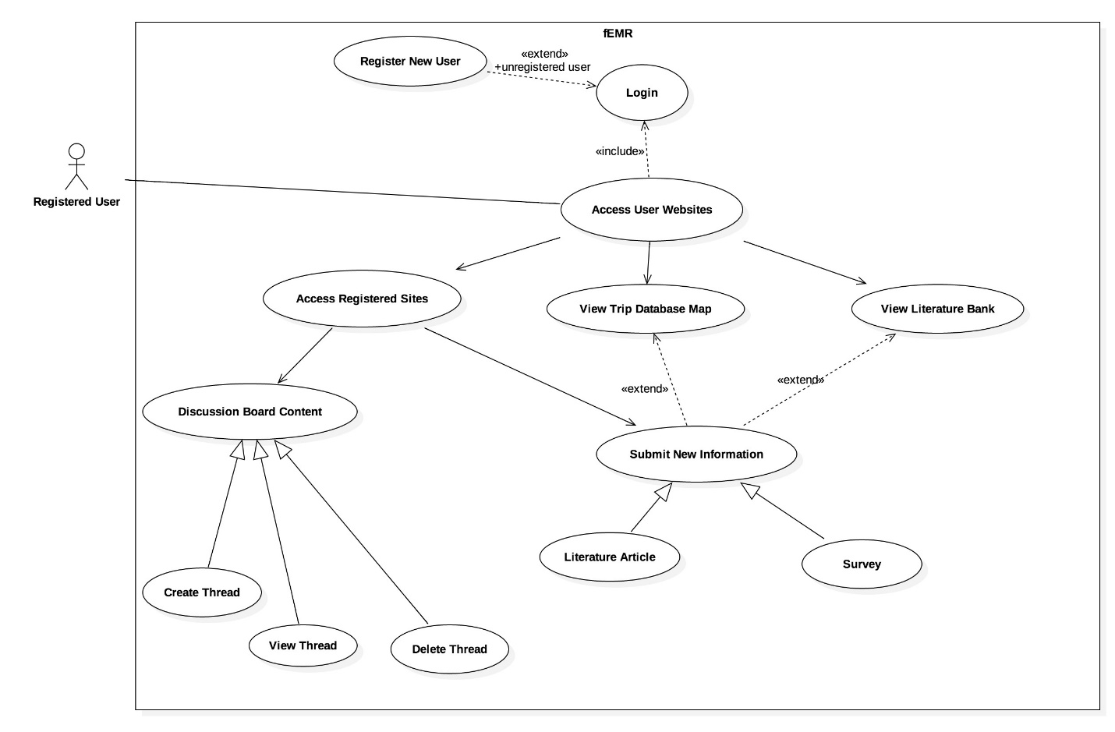

## **4.1.b** **Use Case Tables**

**Use Case 1: Register**

|  |  |
| --- | --- |
| Use case ID: | UseCase_1 |
| Use case name: | Register |
| Created by: | Arooba Javed |
| Date created: | 03/05/2016 |
| Actors: | fEMR users |
| Description: | The user will be able to register for an account in order to log in and gain access to features that are meant for registered users only. |
| Trigger: | The user wishes to register on the website in order to gain access to more features |
| Preconditions: | The user accesses the web pages via a laptop, desktop computer or mobile computing device. |
| Postconditions: | The user has now registered for an account on the website and can log in to the account to gain access to features that are meant for registered users only. |
| Normal flow: | 1. User goes to “Login” page. 2. User clicks on “Create account” and enters an email address and password. 3. User has the ability to log in to his/her account and access features such as posting to the Discussion Board, adding a trip to the Trip Database and adding resources to the Literature Bank. |
| Alternate flow: | The user already has an account and logs in or chooses not to create an account. |
| Assumptions: | User is accessing the web page via their web-enabled computing device. |
| Exceptions: | N/A |

**Use Case 2: Login**

|  |  |
| --- | --- |
| Use case ID: | UseCase_2 |
| Use case name: | Login |
| Created by: | Arooba Javed |
| Date created: | 03/05/2016 |
| Actors: | fEMR users |
| Description: | The user will be able to log in to their account in order to gain access to features that are meant for registered users only. |
| Trigger: | The user has an account and wishes to log in to access features that are meant for registered users only. |
| Preconditions: | The user has registered on the website in order to gain access to more features. |
| Postconditions: | The user has now logged in to their account on the website and can access to features that are meant for registered users only. |
| Normal flow: | 1. User goes to “Login” page.  2. User enters an email address and password in order to log in to their account.  3. User can now access features such as posting to the Discussion Board, adding a trip to the Trip Database and adding resources to the Literature Bank. |
| Alternate flow: | The user does not have an account and must create one or does not wish to log in to their account. |
| Assumptions: | User is accessing the web page via their web-enabled computing device and is registered on the website. |
| Exceptions: | N/A |

**Use Case 3: Trip Database Map**

|  |  |
| --- | --- |
| Use case ID: | UseCase_3 |
| Use case name: | Trip Database Map |
| Created by: | Rachel Dorn |
| Date created: | 03/10/2016 |
| Actors: | fEMR users |
| Description: | All users can access the Trip Database map and the links that go to detailed information on each trip. |
| Trigger: | User clicks on a link that pops up when user clicks on a pin on the Google maps API to access a trip |
| Preconditions: | User has accessed the web page via their internet-capable device |
| Postconditions: | User has clicked on the trip they wish to gain information on from the Google map API. This has led them to the bottom portion of the Trip Database page, where there is more information listed about the trip |
| Normal flow: | 1. User looks at the Google map on the Trip Database web page and clicks on a pin in a city they are interested in and then a popup window appears showing hyperlinks of all the trips to that city. The user clicks on the trip they wish to learn more about. 2. The link regarding the trip leads the web page to jump to the bottom of the page, where there is information listed regarding the trip and medical team that went on the trip. |
| Alternate flow: | The user does not find a trip they are interested in learning more about and therefore does not click on any links on the Google maps API |
| Assumptions: | User is accessing the web page via their web-enabled computing device |
| Exceptions: | N/A |

**Use Case 4: Trip Database Survey**

|  |  |
| --- | --- |
| Use case ID: | UseCase_4 |
| Use case name: | Trip Database Survey |
| Created by: | Rachel Dorn/Arooba Javed |
| Date created: | 03/10/2016 |
| Actors: | fEMR Registered users |
| Description: | Registered user will complete and submit a survey to add a trip to the Trip Database |
| Trigger: | User does not find their trip information on the Google map on the Trip Database page so clicks on the link located to the left of the map. |
| Preconditions: | User has registered on the site and logged in using their email and password credentials |
| Postconditions: | User has submitted the Trip Database survey and awaits approval from the fEMR moderators for their trip to show up on the map. |
| Normal flow: | 1. User looks at the Google map on the Trip Database web page but does not find their medical volunteer trip listed on the map  2. User clicks link to left of map to add their trip to the database  3. User completes and submits survey in order to ask moderator to approve their trip to be added to the Trip Database. |
| Alternate flow: | The user finds their trip listed in the Google map for the Trip Database. This renders the survey to add a trip useless for this particular user |
| Assumptions: | User is registered with the website and does not find their trip on the Trip Database |
| Exceptions: | N/A |

**Use Case 5: Email sent to Moderator**

|  |  |
| --- | --- |
| Use case ID: | UseCase_5 |
| Use case name: | Email sent to Moderator (via a user filling out a survey) |
| Created by: | Arooba Javed/Rachel Dorn |
| Date created: | 03/10/2016 |
| Actors: | fEMR moderators |
| Description: | Once a registered user submits a Trip Database survey, the moderator receives an email that allows them to approve or deny the addition to the Trip Database |
| Trigger: | User submits a survey to add a trip to the Trip Database |
| Preconditions: | Registered user completes and submits a Trip Database survey |
| Postconditions: | Moderator clicks on link in their email to go to the approvals webpage. |
| Normal flow: | 1. User completes and submits a Trip Database survey 2. Moderator receives an email, which allows them to go directly to the approvals page via a hyperlink in the email. |
| Alternate flow: | The user does not submit a survey to add to the Trip Database |
| Assumptions: | User is accessing the web page via their web-enabled computing device and is registered on the website, moderator is registered on the website and is logged in to their moderator account and email |
| Exceptions: | N/A |

**Use Case 6: Survey Approvals**

|  |  |
| --- | --- |
| Use case ID: | UseCase_6 |
| Use case name: | Survey Approvals |
| Created by: | Rachel Dorn / Arooba Javed |
| Date created: | 03/10/2016 |
| Actors: | fEMR moderators |
| Description: | The moderator goes to the survey approvals page to approve or deny the addition to the Trip Database. If approved, this trip shows up in the Trip Database |
| Trigger: | Email is sent to moderator asking for approval to add the trip to the Trip Database. |
| Preconditions: | Moderator receives email asking for approval to add the trip to the Trip Database. The Moderator then clicks on the hyperlink in the email and goes to the survey approvals page. |
| Postconditions: | Moderator either approves or denies a user’s request to add a trip to the Trip Database |
| Normal flow: | 1. Moderator receives an email, which allows them to either approve or deny the user’s request to add their trip to the Trip Database 2. Based on the moderator’s decision, the trip is either not added or is added to the Google map API/the Trip Database at the bottom of the Trip Database web page. |
| Alternate flow: | An email is not sent. |
| Assumptions: | Moderator is registered on the website and is logged in to their moderator account and email |
| Exceptions: | N/A |

**Use Case 7: Automatic Backup**

|  |  |
| --- | --- |
| Use case ID: | UseCase_7 |
| Use case name: | Automatic Backup |
| Created by: | Rachel Dorn/ Arooba Javed |
| Date created: | 03/10/2016 |
| Actors: | fEMR moderators |
| Description: | The Trip Database is automatically backed up on a regular schedule to an Amazon S3 server |
| Trigger: | Time for backup is reached. |
| Preconditions: | Server is online and scheduled for backups. |
| Postconditions: | The Trip Database is backed up to an Amazon S3 server on a routine schedule. |
| Normal flow: | 1. The Trip Database is backed up regularly and automatically to the Amazon S3 server. |
| Alternate flow: | Time is not yet reached for automatic backup to occur. |
| Assumptions: | Server is online and website is operational. |
| Exceptions: | N/A |

**Use Case 8: Literature Article Submission**

|  |  |
| --- | --- |
| Use case ID: | UseCase_8 |
| Use case name: | Literature Article Submission |
| Created by: | Rachel Dorn/ Arooba Javed |
| Date created: | 03/10/2016 |
| Actors: | fEMR users |
| Description: | Registered users can access the link on the Literature Bank website to add an article. User fills out form and clicks submit. |
| Trigger: | User clicks on link to add an article for to the Literature Bank. |
| Preconditions: | Registered user wishes to add a useful resource to the Literature Bank |
| Postconditions: | User has submitted an article for moderator approval, which may show up on the Literature Bank page (if approved). |
| Normal flow: | 1. User looks at the Literature Bank web page and does not find a particular article, which they think will be useful. 2. User clicks on the link to the Literature Bank survey and submits a link to an article for moderator approval. |
| Alternate flow: | The user does not have an article they wish to add to the Literature Bank and therefore does click on the link to add an article to the Literature Bank page |
| Assumptions: | User is accessing the web page via their web-enabled computing device and is registered on the website. |
| Exceptions: | N/A |

**Use Case 9: Literature Bank**

|  |  |
| --- | --- |
| Use case ID: | UseCase_9 |
| Use case name: | Literature Bank. |
| Created by: | Arooba Javed / Rachel Dorn |
| Date created: | 03/10/2016 |
| Actors: | fEMR users |
| Description: | Users can click on the links in the Literature Bank to access resource articles that were posted there by other users**.** |
| Trigger: | The user wishes to access articles that were posted on the Literature Bank by other users. |
| Preconditions: | The user is accessing the website via their laptop, desktop computer or mobile computing device. |
| Postconditions: | The user has now clicked on articles listed in the Literature Bank and accessed resources that were posted there. |
| Normal flow: | 1. User goes to the Literature Bank page.  2. User clicks on a link to a resource that was posted on the web page. |
| Alternate flow: | The user does not wish to access the resources on the Literature Bank page. |
| Assumptions: | User is accessing the web page via their web-enabled computing device. |
| Exceptions: | N/A |

**Use Case 10: Users can create a thread to post to the Discussion Board**

|  |  |
| --- | --- |
| Use case ID: | UseCase_10 |
| Use case name: | Users can create a thread to post to the Discussion Board |
| Created by: | Arooba Javed |
| Date created: | 03/05/2016 |
| Actors: | fEMR moderators |
| Description: | Once a registered user logs in to their account, they have the ability to create a thread on the Discussion Board and post a question for other fEMR users to answer |
| Trigger: | Registered user scans Discussion Board, does not see an answer to the query in their mind and chooses to create a thread on the Discussion Board to post their question. |
| Preconditions: | User is registered, logged in and has a question that they wish to post to the Discussion Board web page |
| Postconditions: | User has successfully created a thread and posted to the Discussion Board |
| Normal flow: | 1. Registered user clicks on the Discussion Board page and scans it for an answer to his/her question.  2. User creates a thread on the Discussion Board.  3. The user’s query is successfully posted to the Discussion Board. |
| Alternate flow: | The user sees the answer to their query on the Discussion Board and chooses not to create a thread on there. |
| Assumptions: | User is accessing the web page via their web-enabled computing device and is registered on the website. |
| Exceptions: | N/A |

**Use Case 11: Users can view and/or reply to others’ posts on the Discussion Board**

|  |  |
| --- | --- |
| Use case ID: | UseCase_11 |
| Use case name: | Users can view and/or reply to others’ posts on the Discussion Board |
| Created by: | Arooba Javed / Rachel Dorn |
| Date created: | 03/10/2016 |
| Actors: | fEMR registered users |
| Description: | Once a registered user logs in to their account, they have the ability to view and/or reply to a thread on the Discussion Board and answer another fEMR user’s question. |
| Trigger: | Registered and logged in user scans Discussion Board, sees a question from another fEMR user and chooses to respond to the other user’s query |
| Preconditions: | User is registered, logged in and has a question that they wish to reply to another user’s Discussion Board post. |
| Postconditions: | User has successfully replied to another user’s query on the Discussion Board |
| Normal flow: | 1. Registered user clicks on the Discussion Board page and sees another user’s query  2. User chooses to reply to the user’s query  3. User’s response is successfully posted to the Discussion Board |
| Alternate flow: | The user sees another user’s query on the Discussion Board and chooses not to respond to it. |
| Assumptions: | User is accessing the web page via their web-enabled computing device and is registered on the website. |
| Exceptions: | N/A |

**Use Case 12: Discussion Board Deletes**

|  |  |
| --- | --- |
| Use case ID: | UseCase_12 |
| Use case name: | Discussion Board Deletes |
| Created by: | Rachel Dorn |
| Date created: | 03/10/2016 |
| Actors: | fEMR Moderators |
| Description: | Moderators can delete threads on the discussion board. |
| Trigger: | Moderator clicks on the delete option for a thread on the discussion board. |
| Preconditions: | Moderator sees a post on the discussion board that is not appropriate for the site. |
| Postconditions: | Post is deleted from the discussion board. |
| Normal flow: | 1. The moderator selects post to be deleted. 2. Thread is deleted from the discussion board. |
| Alternate flow: | Moderator does not choose to delete a thread. |
| Assumptions: | N/A |
| Exceptions: | N/A |

**Use Case 13: moderators grant registered users privileges**

|  |  |
| --- | --- |
| Use case ID: | UseCase_13 |
| Use case name: | Moderators approve registered users |
| Created by: | Daniel Lipford |
| Date created: | 03/10/2016 |
| Actors: | fEMR moderators |
| Description: | Moderators approve potential users on a webpage on the femr website |
| Trigger: | a user successfully registers. |
| Preconditions: | User is registered, logged in and has a question that they wish to reply to another user’s Discussion Board post. |
| Postconditions: | Registered users’ privileges are granted |
| Normal flow: | 1. moderator receives email  2. moderator clicks link  3. moderator approves user via tick mark |
| Alternate flow: | 3.moderator doesn’t approve user |
| Assumptions: | n/a |
| Exceptions: | N/A |

## **4.2** **Sequence Diagram**

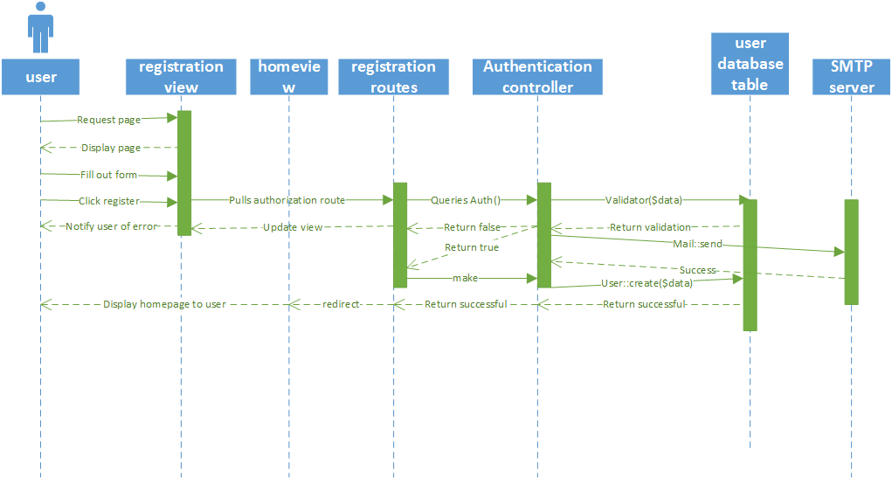

**Figure 1: Sequence Diagram for Use Case 1**

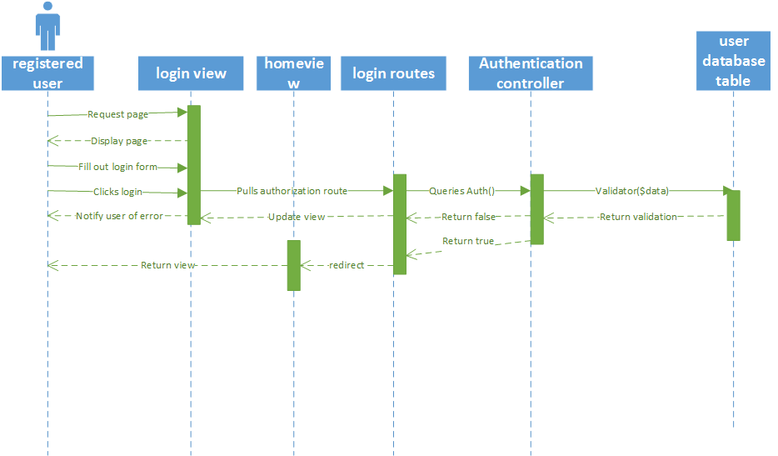

**Figure 1: Sequence Diagram for Use Case 2**

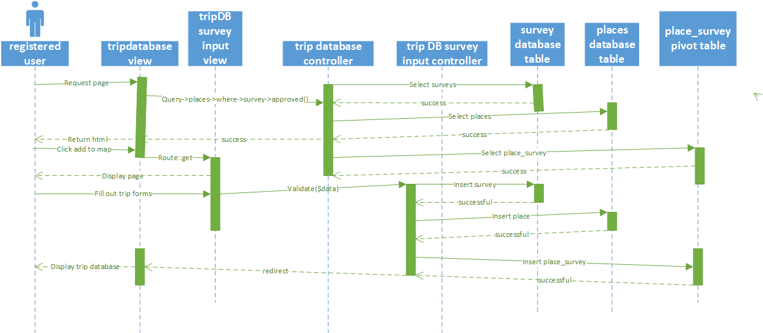

**Figure 2: Sequence Diagram for Use Case 3,4**

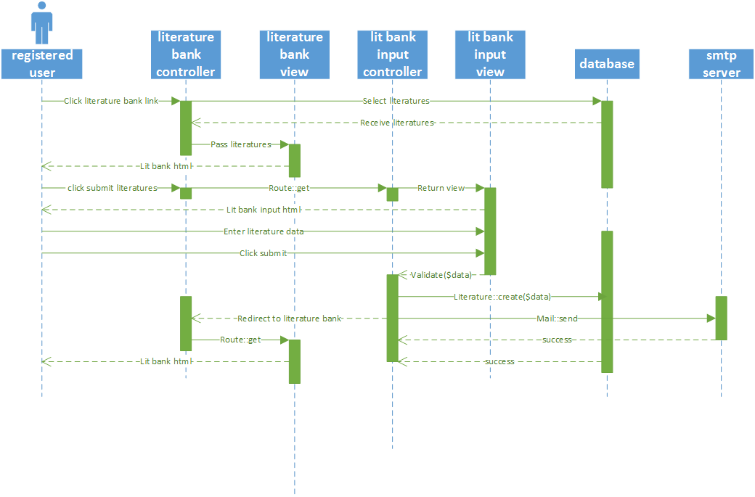

**Figure 3: Sequence Diagram for Use Case 8, 9**

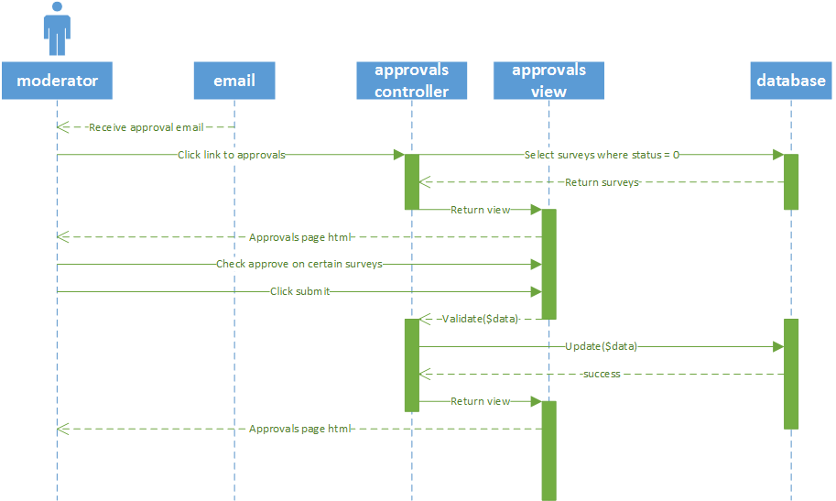**Figure4: Sequence Diagram for Use Case 6**

## **4.3 Data Flow Diagram**

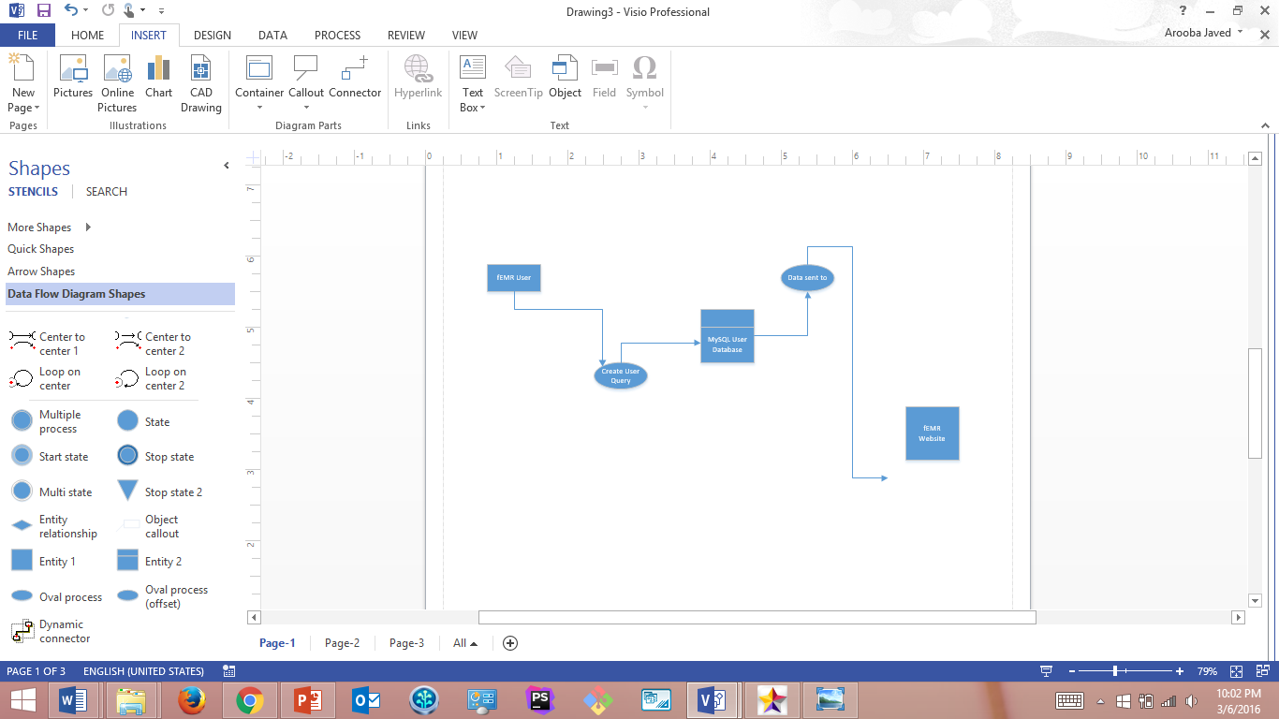

**Figure 5: Data Flow Diagram for Use Case 1, 2**

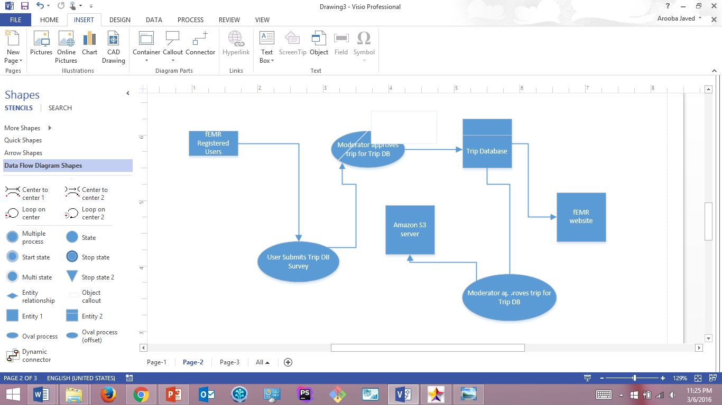

**Figure 6: Data Flow Diagram for Use Case 4, 5, 6, 7**

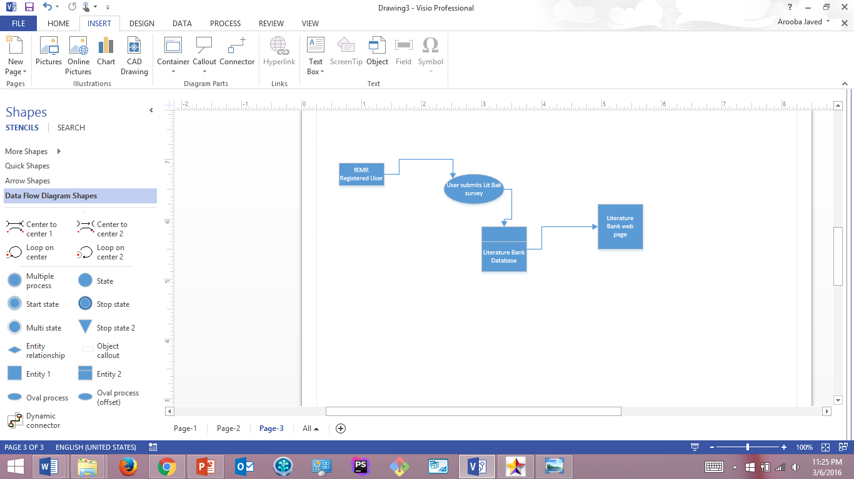

**Figure 7: Data Flow Diagram for Use Case 8, 9**

## **4.4** **Database Design**

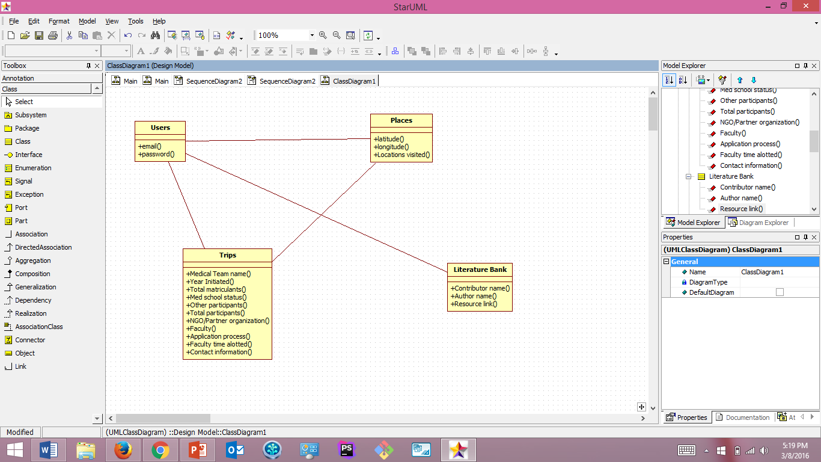

**Figure 8: Database Design Diagram**

## **4.5** **Class diagram**



**Figure 8: Class Diagram**

## **4.6** **Application Program Interfaces**

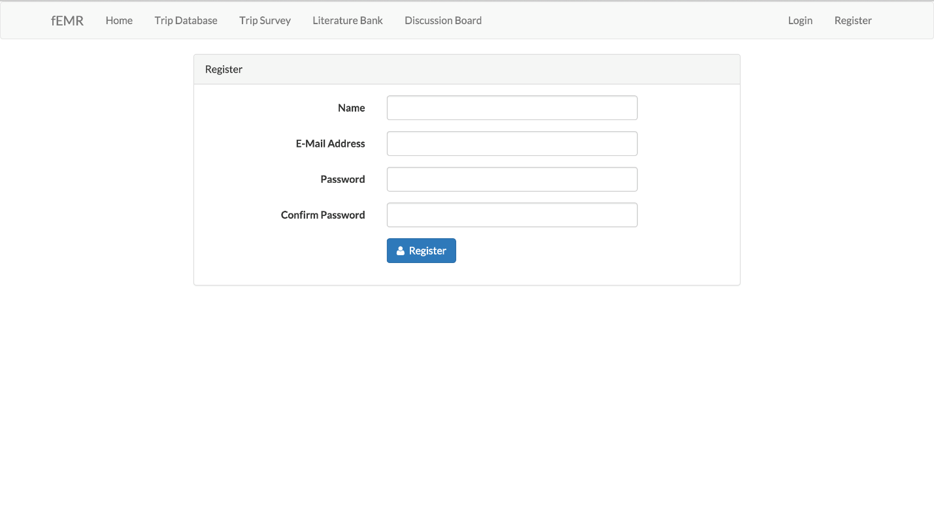

**User Registration page**

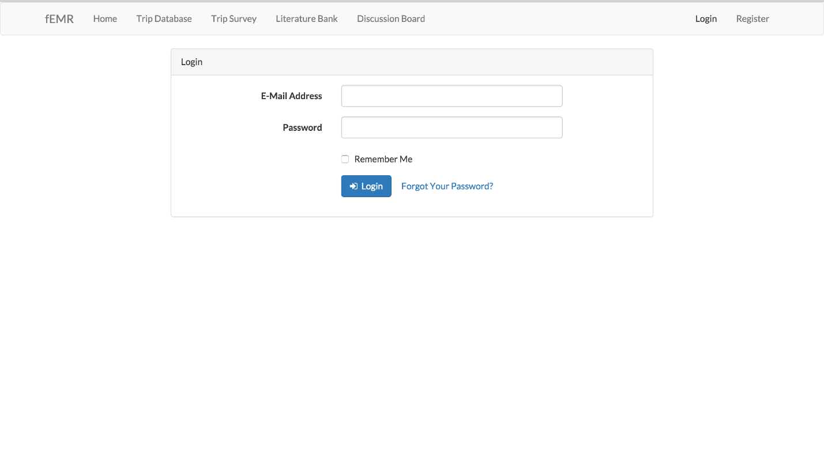

**User Login page**

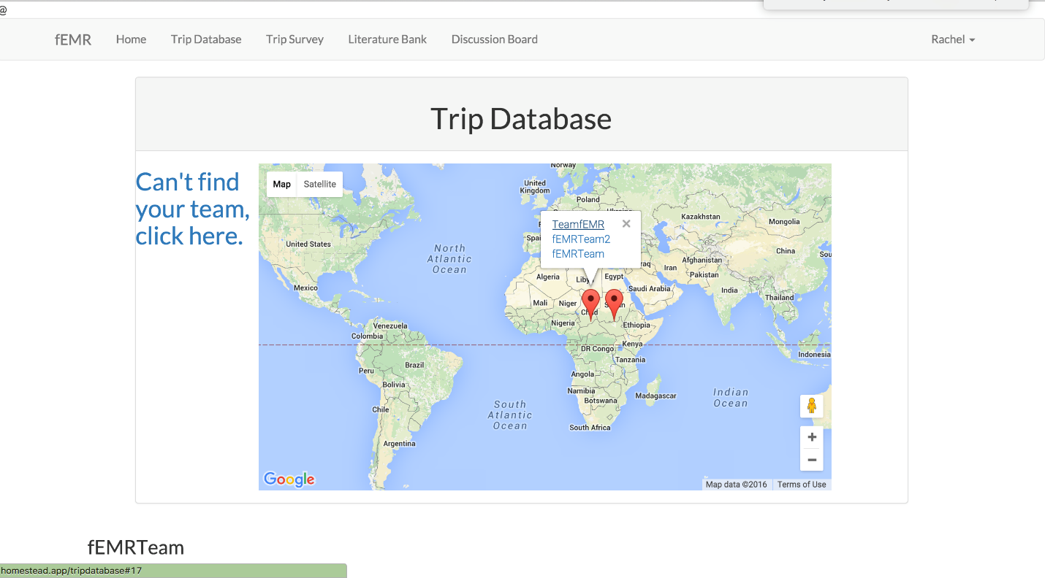

**Trip Database web page**

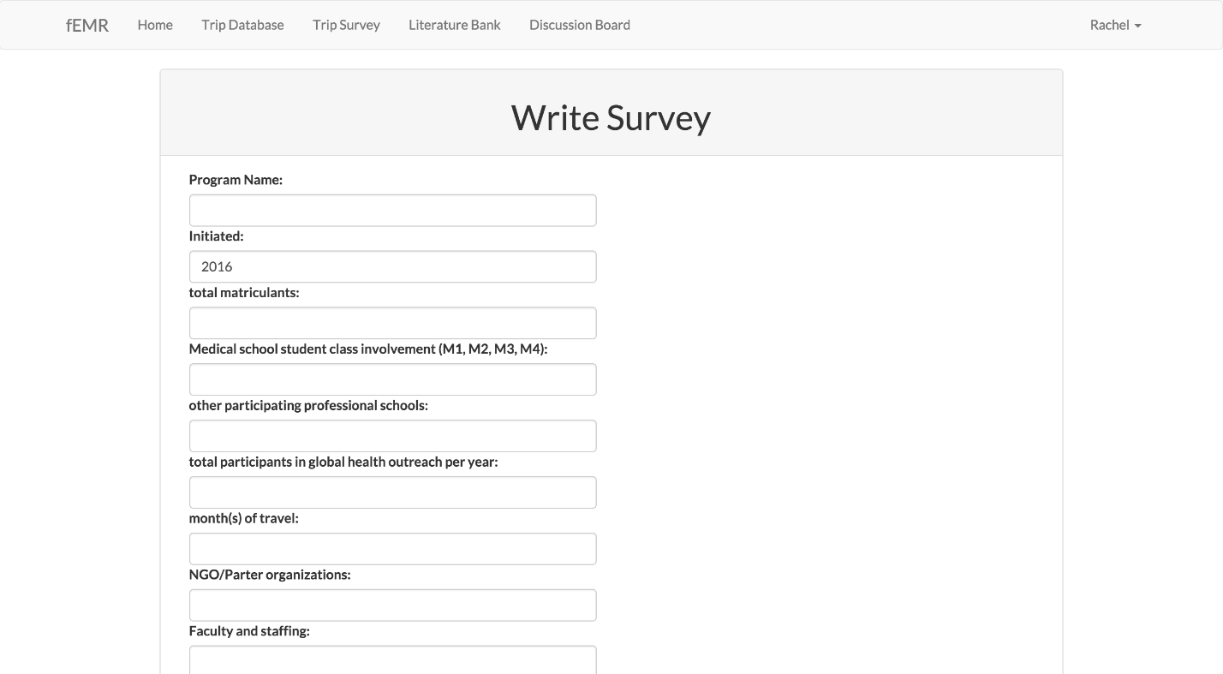

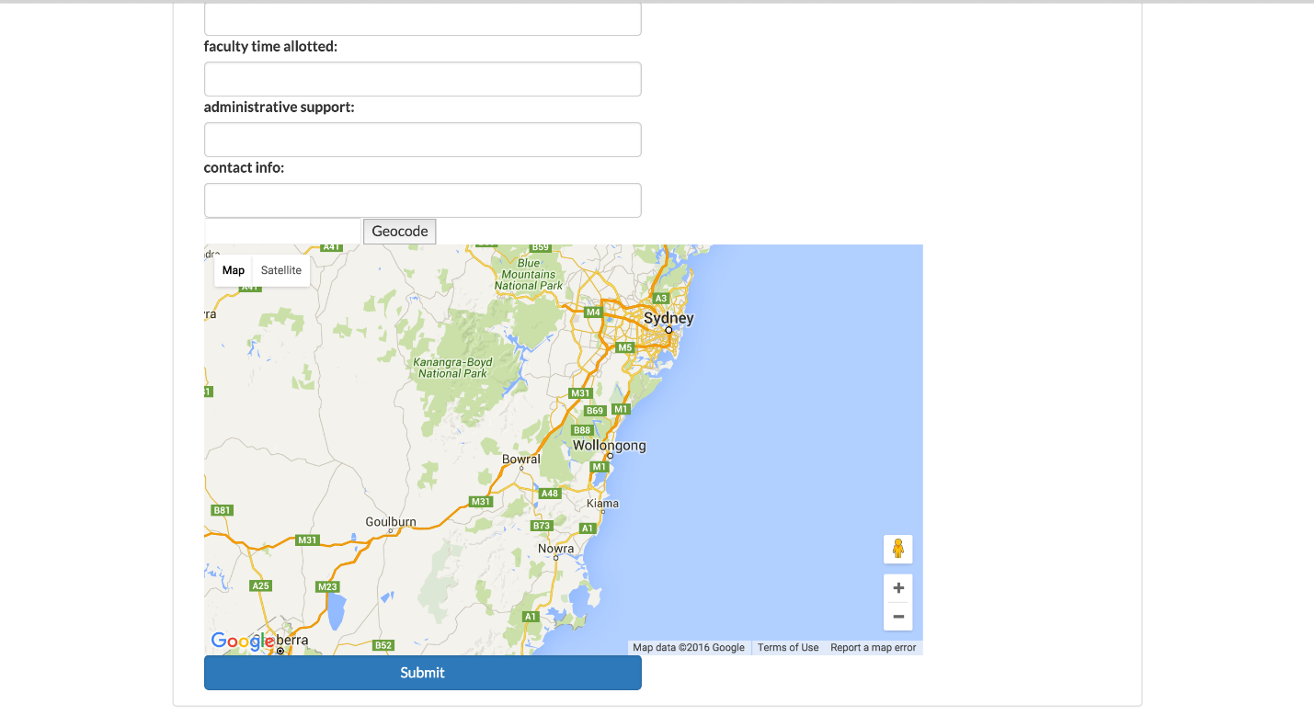

**Trip Database Survey**

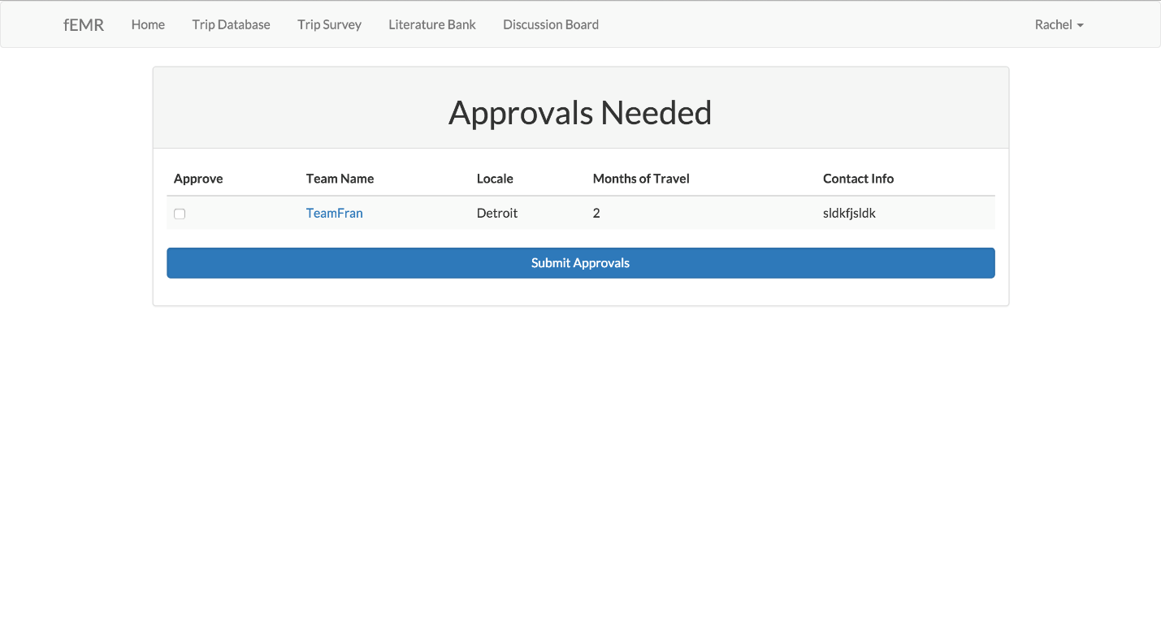

**fEMR Moderator Approval page**

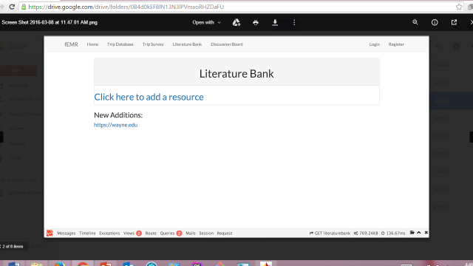

**Literature Bank web page**

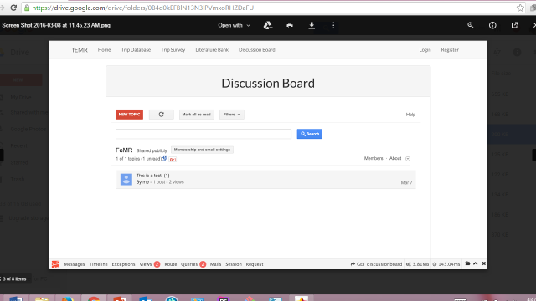

**Discussion Board web page**

## **4.7** **User Interface Design**

The Literature Bank page is a simple web page with a straightforward design. The Discussion Board web page will be designed similarly to the discussion board found on the website “Redit”.

The current design of the Trip Database web page is reflected below:

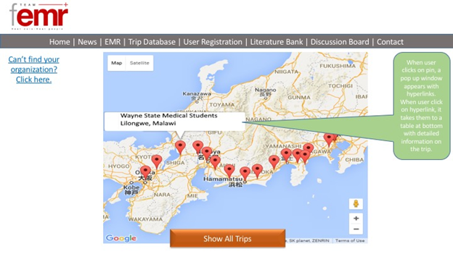

# **5** **Product Design Specification Approval**

The undersigned acknowledge they have reviewed the *fEMR* **Product Design Specification** document and agree with the approach it presents. Any changes to this Requirements Definition will be coordinated with and approved by the undersigned or their designated representatives.

|  |  |  |  |
| --- | --- | --- | --- |
| Signature: |  | Date: |  |
| Print Name: | Khayyam Hashmi |  |  |
| Title: | CSC 4996 Instructor |  |  |
| Role: | CSC 4996 Instructor |  |  |

|  |  |  |  |
| --- | --- | --- | --- |
| Signature: |  | Date: |  |
| Print Name: | Dr. Sam Bryfczynski |  |  |
| Title: | CSC 4996 Instructor |  |  |
| Role: | CSC 4996 Instructor |  |  |

|  |  |  |  |
| --- | --- | --- | --- |
| Signature: | Arooba Javed | Date: | 03/06/2016 |
| Print Name: | Arooba Javed |  |  |
| Title: | fEMR Team Lead |  |  |
| Role: | fEMR Team Lead |  |  |

Appendix A: References

N/A.

Appendix B: Key Terms

The following table provides definitions for terms relevant to this document.

|  |  |
| --- | --- |
| Non-registered user | someone who interacts with the fEMR website but is not registered as a user |
| Registered User | Someone who registered an account and is logged in on the website for the purposes of discussion board posting, literature bank posting, and posting to the trip database. |
| Users | Refers to the general category of users, who can be registered or non-registered |
| Team fEMR Moderator(s) | The moderators of content posted to the discussion boards, literature bank, or to the trip database. Approves unregistered users’ posts. Approves newly registered accounts to post on the site. |
| Team fEMR Admin/Administrator(s) | The administrator(s) of the website. Grants registered users Moderator privileges. Has all features of a moderator. Can delete user accounts, users’ posts, approve user posts? |
| fEMR system | Fast electronic medical records system. The open-source electronic medical record system that is distributed on teamfemr.org for transient medical team use. |
| Medical Team | A group of people who volunteer overseas to give medical services to those living in third world countries. The target audience for TeamfEMR.org. |
| Web API | Application programming web interface for a web server to connect with for recurring retrieval of certain data in a certain format. |
| Cloud Storage | A third party web host for storage of data. |